Class members

Class allowed to define 3 members :

1. Variables
2. Blocks
3. Methods

Variable :

1. Providing identities to standard memory locations.
2. While storing data, data will go and store randomly.
3. Without identities we cannot access the data once it has been stored.

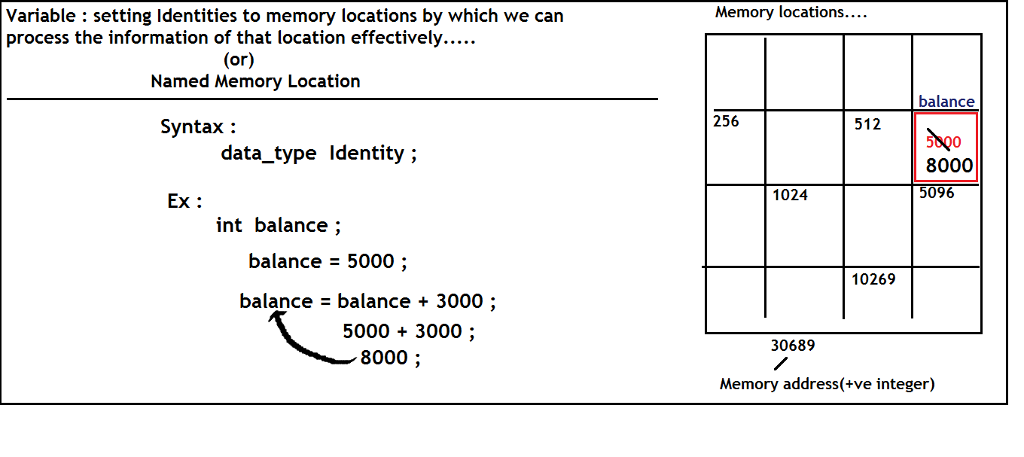

Static variables v/s Non-static variables :

1. Variables which are common for all the objects must be declared as static.
2. Variables which are specific to Object must be defined as non-static
3. Static variable get memory allocation only once.
4. Non-static variables get memory allocation in every object.

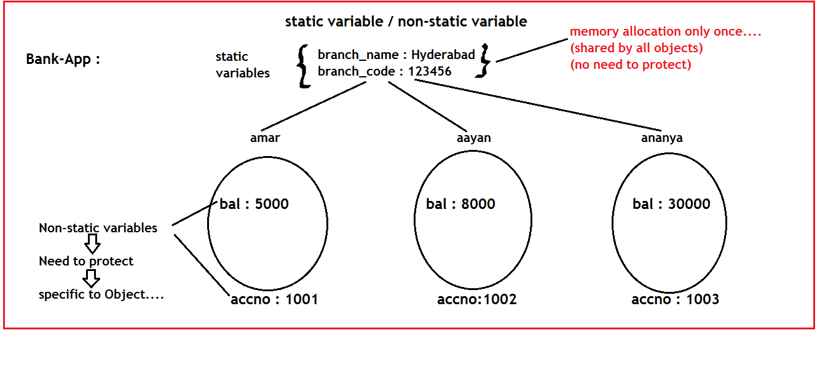

Block :

1. Set of Instructions having no identity…..
2. We cannot call explicitly (no identity)….
3. JVM invokes implicitly every block…….

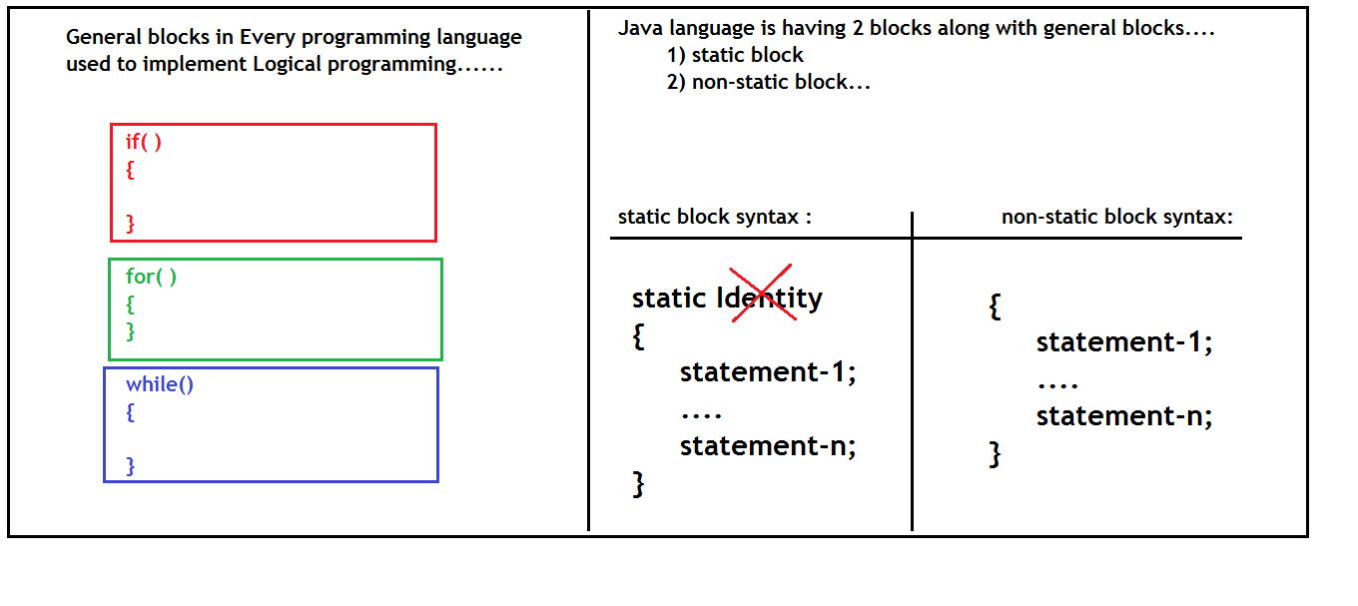

Ques : what is the use of block ?

Ques : What type of information need to place inside the block ?

Ques : When block get executes ?

Ans : to start communicating with any object, basic information is required.

Static block & non-static block is responsible for providing basic info of object …..

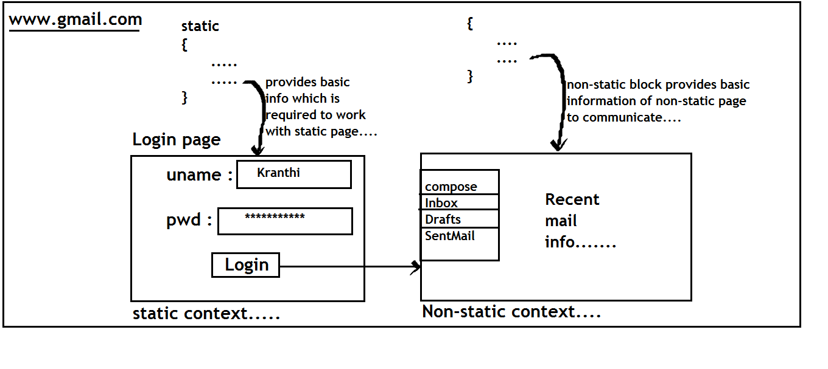

Methods :

1. A block of instructions having Identity.
2. Every method is taking input, processing input and returns output.
3. Every method must be called explicitly(using its identity).

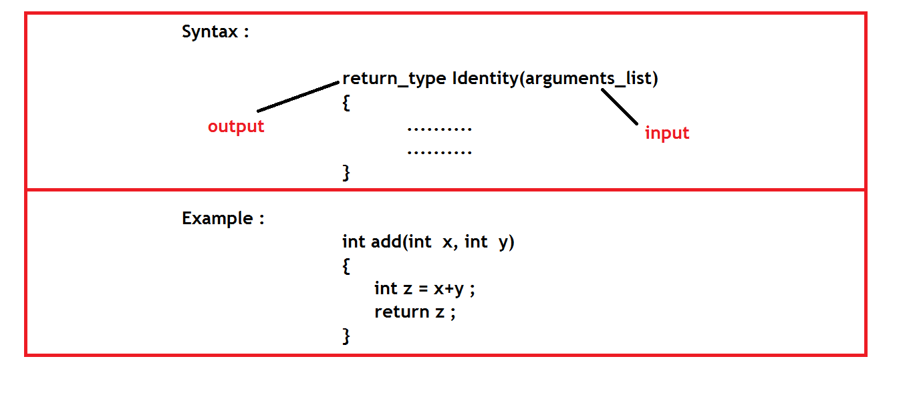

Note : Every method is having 2 main things.

1. Method definition 🡪block
2. Method call 🡪 single statement

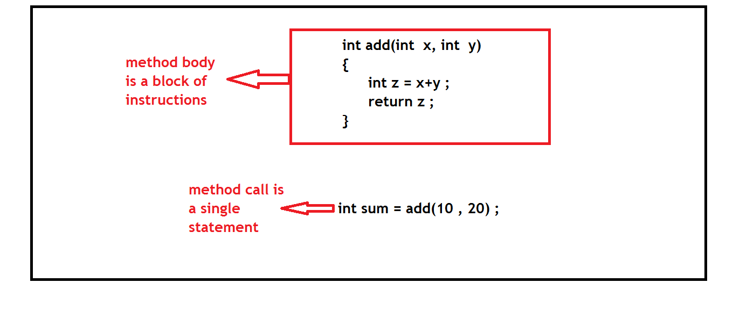

Why we need to call a method explicitly?

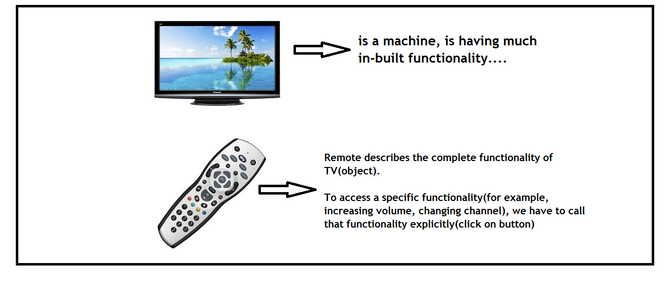

Difference between block and method?

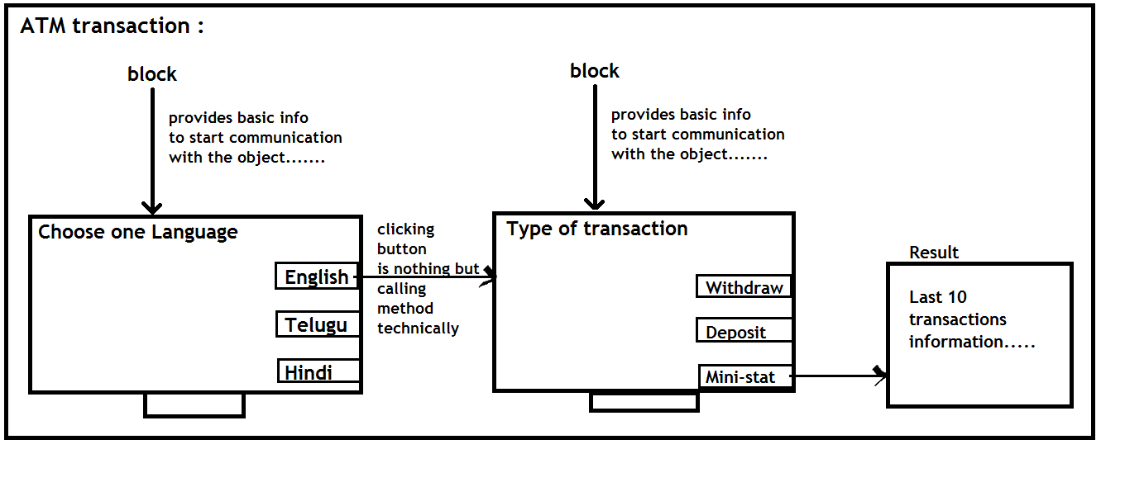

Classification of Methods :

1. No arguments and No return values
2. With arguments and No return values
3. With arguments and With return values
4. No arguments and With return values

